United Nations Population Fund (UNFPA)
Mongolia Country Office

UN Street-14, Sukhbaatar District
Ulaanbaatar-14201, Mongolia

Website: http://mongolia.unfpa.org

For further information about the report, please contact Dr.Tsedmaa Baatar, SRHR programme analyst, at baatar@unfpa.org.

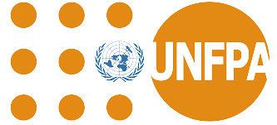 |  | South-to-South Cooperation  South-South Exchange on Telemedicine Experience  Mongolia and the Islamic Republic of Mauritania  [September 16-23, 2023]  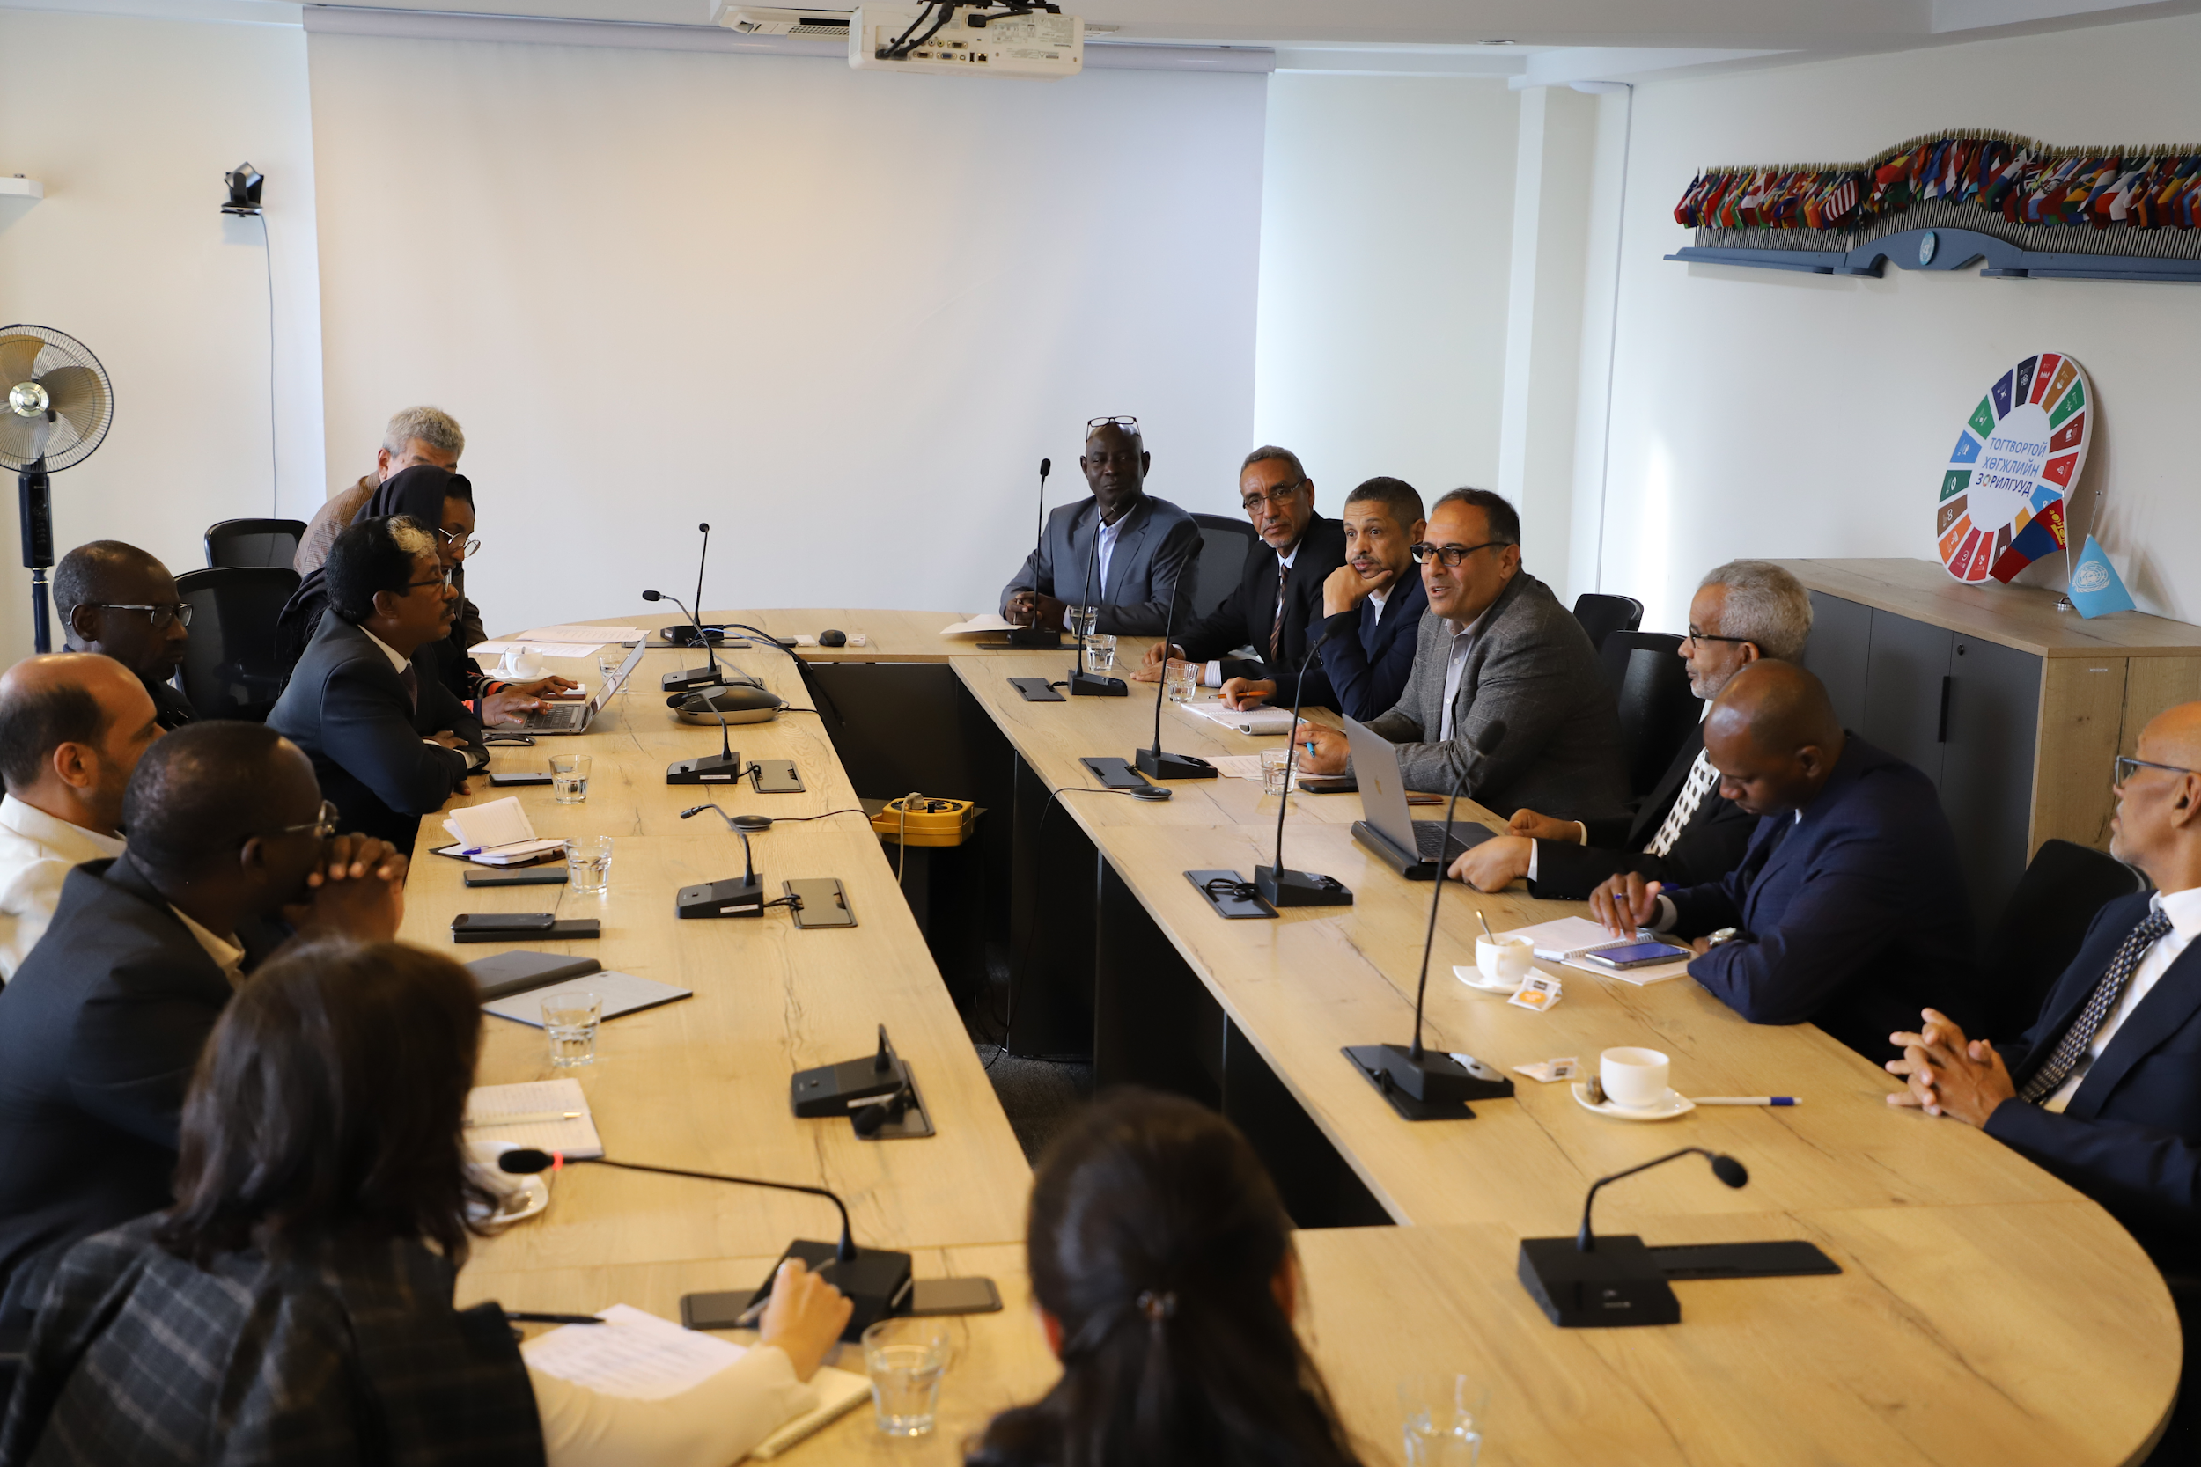  Executive Summary  The UNFPA Mongolia Country Office, in collaboration with the UNFPA Mauritania Country Office, organized a study tour for a Mauritanian delegation with the goal of learning from Mongolia's successful experiences in utilizing telemedicine to address maternal and newborn complications. This mission took place from September 16 to September 23, 2023.  The mission aimed to facilitate the exchange of knowledge and best practices in the application of telemedicine for maternal and newborn care, and to strengthen collaboration between Mauritania and Mongolia, with a specific focus on reducing preventable maternal mortality.  During the mission, the Mauritanian delegation visited several institutions in Mongolia, including the Ministry of Health (MOH), the National Center for Maternal and Child Health (NCMCH), the School of Nursing and Midwifery at the Mongolian National University of Medical Sciences, and a General Hospital in a province to explore about Mongolian’s health system structure, MCH policy, and program in relation to Telemedicine. Through these visits and discussions with key stakeholders, the delegation had the opportunity to observe and learn from Mongolia's telemedicine initiatives and best practices in the country's healthcare settings.  The Study Tour for the Mauritania delegation was a successful knowledge-sharing endeavor that achieved several important objectives. It promoted collaboration, enhanced capacity, and contributed to the application of telemedicine as an efficient tool to improve the quality of maternal and child health services in Mauritania. Furthermore, it is the first step for strengthening of continuous collaboration in the ongoing efforts to reduce maternal and newborn mortalities and morbidities in both Mauritania and Mongolia.

Introduction
Although Mauritania and Mongolia are geographically and culturally distinct, they share similarities in terms of population size, land size, geographic peculiarities, and common challenges in sexual reproductive and maternal and child health care delivery. Both countries are committed to reducing preventable maternal mortality, aligning with the UNFPA's core mandate and the Sustainable Development Goals (SDGs). While progress has been made in reducing maternal mortality in both countries, Mongolia has made significant progress in the reduction of maternal mortality and is potentially on track to achieve the SDG target. In contrast, Mauritania continues to face significant challenges in this regard, with disparities in access to healthcare, particularly in rural areas. For example, with a significant reduction in maternal mortality from 582 per 100,000 live births in 2013 to 424 per 100,000 live births in 2020, maternal mortality remains still higher in Mauritania. In addition, Mauritania faces challenges in access to emergency obstetric care, with a limited number of Basic and Comprehensive EmONC facilities. This presents a barrier to timely and quality care for pregnant women, particularly in rural and isolated areas. Furthermore, a shortage of qualified healthcare personnel at all levels of the healthcare system in Mauritania is another challenge for delivering quality and timely healthcare, especially in maternal and newborn health.
To reverse those challenges, the Ministry of Health in Mauritania has developed a national plan for the development of human resources for health, covering the period from 2022 to 2026. This long-term plan includes the use of telemedicine and e-learning platforms to strengthen the skills of healthcare staff with the support of the SWEDD project. Establishing a nationwide telemedicine platform as a key initiative included in the national plan requires search and learning of best practices on successes and lessons from countries like Mongolia where Telemedicine was well documented as an innovation in reducing maternal mortalities and morbidities. Mongolia's telemedicine project “Telemedicine support for maternal and newborn health” supported by the Luxembourg government and the UNFPA, is an international award-winning initiative. Through this initiative, the fully functional maternal and neonatal teleconsultation network has been established to strengthen the capacity of the referral center's team of experts to provide clinical decision-making support to rural doctors by offering quality case management to remote populations. Therefore, at the request of the UNFPA office, in Mauritania, the study tour hosted by UNFPA Mongolia to learn from Mongolia’s success with telemedicine in maternal health. It is also evidence of the power of international collaboration and knowledge sharing within the South and South cooperation. The study tour took place from 16 September to 23 September 2023.
Objectives of the Study Tour
- Learn about the development of telemedicine in Mongolia.
- Understand the benefits and challenges of telemedicine in Mongolia.
- Understand how telemedicine is used for clinical decision-making.
- To identify further opportunities for collaboration between Mongolia and Mauritania in the field of telemedicine.

Methodology
A study tour was a pre-structured and organized visit with well-defined objectives to learn from Mongolia’s telemedicine experiences and practices and explore more insights into the country's context of healthcare policies and telemedicine implementation in Mongolia. The main methodologies used for the study tour were:
1. Meetings and round table discussions with key stakeholders and UNFPA Mongolia program colleagues
2. Sharing knowledge and policy documents on Telemedicine SOP and regulations
3. Site visits to the National Center for Maternal and Child Health and the School of Nursing and Midwifery
4. Field mission to Uvurkhangai Provincial Hospital, including Khujirt soum/village health center
5. Debriefing or wrap-up with UNFPA Mongolia program colleagues

Participants
The composition of the Mauritanian delegation with 11 members representing various key organizations in the Mauritanian healthcare sector was indeed diverse and comprehensive. This diverse team brings together a wealth of knowledge and expertise that can significantly contribute to the success of the study tour and the potential implementation of telemedicine in Mauritania. Each delegate plays a vital role in ensuring a well-rounded and multidisciplinary perspective, which was essential for learning from Mongolia's telemedicine experiences and adapting those lessons to the Mauritanian context.
The presence of representatives from the Ministry of Health, the National Telemedicine Department, public health schools, the SWEDD project, and UNFPA programs covers a wide range of critical areas, including healthcare policy, telemedicine technology, midwifery education, reproductive health, maternal and child health, and supply chain management. This diverse composition allows the delegation to gain insights into various aspects of telemedicine and how it can be effectively integrated into the Mauritanian healthcare system ( Annex 1. TOR of the study tour)
Picture 1. Study tour participants
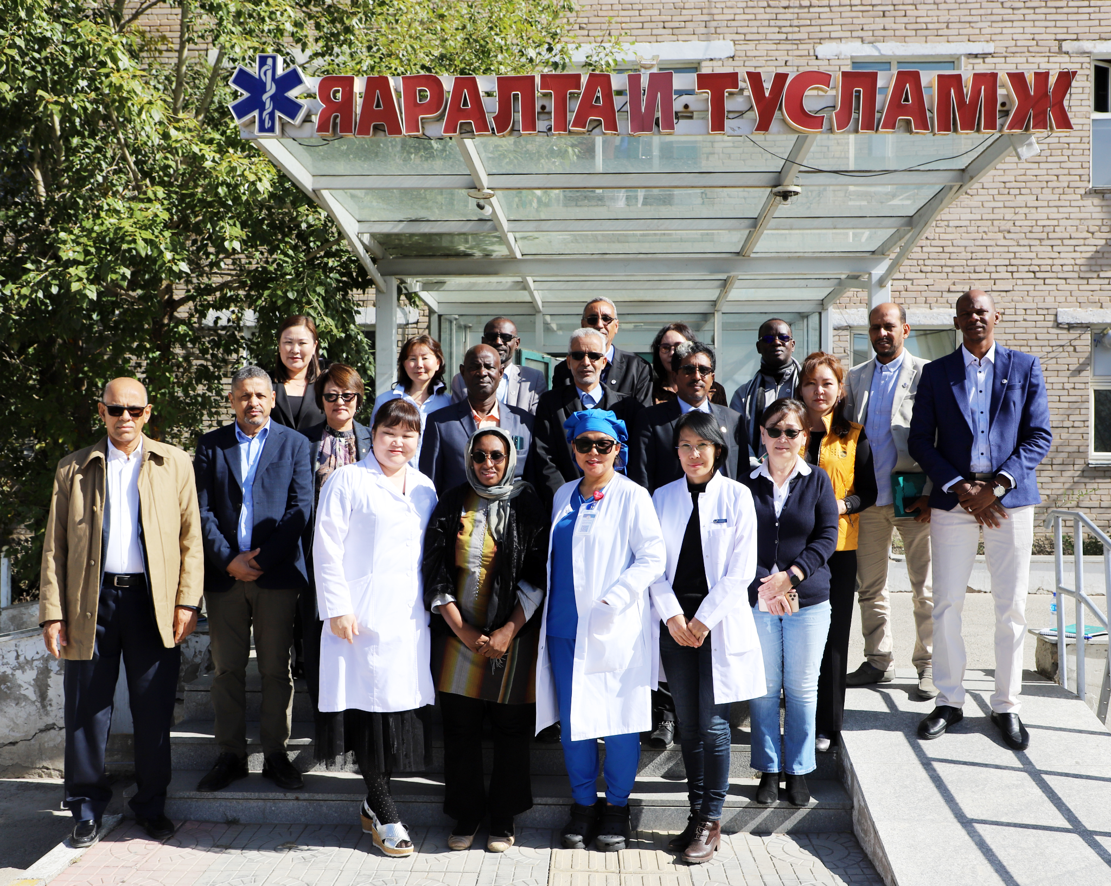
Program Agenda
As a host institution, UNFPA Mongolia developed a comprehensive program for the study tour in close discussion with the delegation of Mauritania included in Annex 2. Study Tour Program. The comprehensive program helped the delegation and the host institution align their expectations and ensured that the study tour was well-organized and goal-oriented.

Key Activities
1. Meetings and round table discussions were held with key stakeholders including UNFPA Mongolia, the officials from MoH, NCMCH, and healthcare providers who are involved in Telemedicine to understand the roles and responsibilities of different stakeholders in the designing and implementation of the project and healthcare policies related to Telemedicine. It helped in understanding the project's structure, governance, and regulatory framework related to digital health in Mongolia.

Picture 2. Meeting with MoH officials

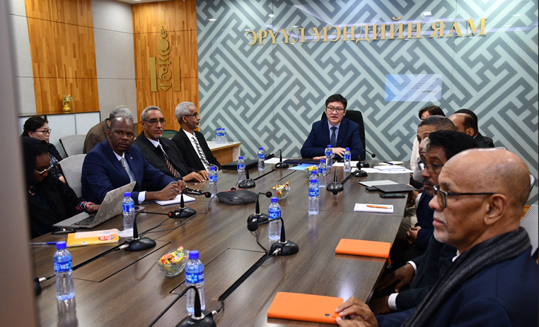

2. Sharing knowledge and policy documents: The study tour provided the Mauritania team with key documents related to telemedicine regulations and Standard Operating Procedures (SoPs) developed by the MoH in Mongolia. Additionally, sharing a PowerPoint presentation on project implementation strategies and lessons learned, as well as project publications, offers reference materials about telemedicine services in Mongolia.

P
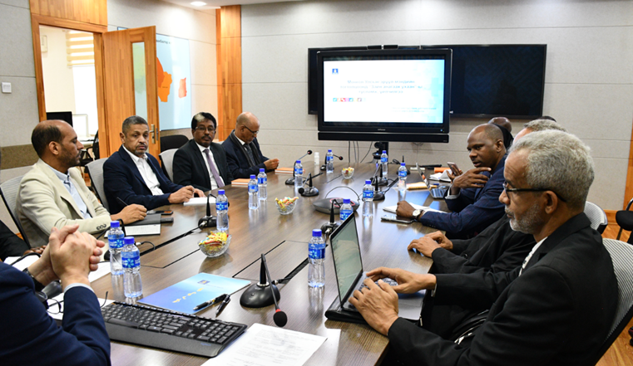
Picture 3. Discussion at MOH on Telehealth regulation

3. Site visits were organized to major hospitals in UB (NCMCH) and the School of Nursing and midwifery in Mongolia where telemedicine has been successfully implemented. The purpose was to observe how the telemedicine system operates, understand the technology used, and identify the impact of telemedicine on healthcare delivery in urban areas. Moreover, the project support for midwifery service reform in Mongolia was introduced with a specific focus on midwifery education upgrading.

Picture 4. Visit the National Center for Maternal and Child Health and observe Teleconsultation.
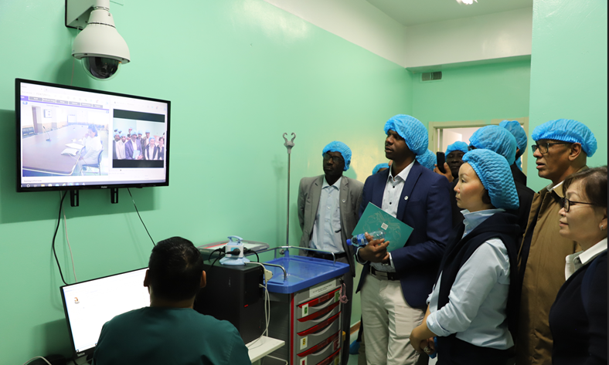

4. Field Visit to one province where the telemedicine system is in operation was facilitated by the UNFPA country office. The aim was to provide the Mauritania team with an understanding of the context of rural healthcare systems in Mongolia and to allow them to witness the practical implementation of telemedicine in remote and underserved areas.

Picture 5. Field visit to Uvurkhangai province

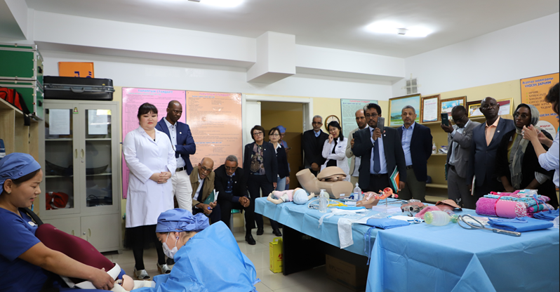

- Debriefing or wrap-up: Conducted a wrap-up session at the end of the study tour, where delegates consolidate the knowledge and experiences gained during the study tour. This session allowed participants to reflect on key takeaways and lessons learned and explore potential areas for further collaboration between the two country offices.

Picture 6. Wrap-up meeting at the UNFPA office

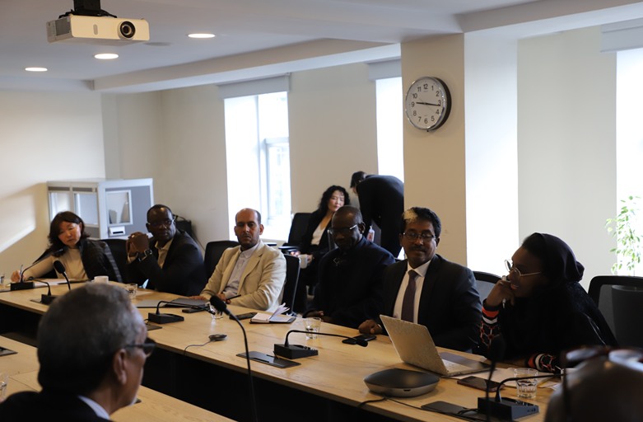

Results
Results:
Knowledge Exchange: The study tour successfully facilitated valuable knowledge sharing between Mauritania and Mongolia. Mauritania gained a deeper understanding of the applications of telemedicine in maternal and newborn care, key strategies for the project implementation include 1). Setting up a fully functional teleconsultation network in maternal health; 2). Staff development and knowledge transfer between participating hospitals, and 3). Set up the multidisciplinary expert team at the NCMCH, and more knowledge on technology used and capacity-building components of the project in rural settings. In addition, the delegates got detailed information on the innovative ideas of the Mongolian experience in telemedicine including the use of Teleconsultation as a simple tool to improve access to specialist care and professional information that creates a professional network between service providers to promote a team spirit over patient care.
Strengthened Collaboration: This initiative served to strengthen collaboration between the two countries, particularly in sexual reproductive, and maternal health. The potential for future partnerships in digital healthcare, including telemedicine and eLearning initiatives, was recognized.
Adaptation of Best Practices: By learning from Mongolia's successful practices in teleconsultation for healthcare, Mauritania can adapt and implement similar solutions to address its own challenges. This includes improving access to maternal and child healthcare services in remote and underserved areas through setting up an expert teleconsultation network and the creation of an e-learning platform for continuous medical education

Lessons Learned
South-South cooperation: The UNFPA in Mongolia has achieved success in hosting a study tour that exemplifies South-South cooperation. This cooperation highlights the importance of working together to address common healthcare challenges, particularly in the context of maternal and child health. Despite the geographical and cultural differences between the participating countries, they share common goals in improving healthcare, and learning from each other's experiences and best practices can help reduce preventable maternal mortality.
Language Barrier: French translation services played a critical role in overcoming language barriers during the mission. Effective communication is essential in any international collaboration or mission, and in this case, French translation services helped bridge the language gap, ensuring that information and ideas could be exchanged smoothly throughout the study tour.
Telemedicine in Mongolia: Telemedicine in Mongolia is highlighted as an efficient use of networks to provide timely and appropriate care. This approach is seen as a valuable lesson for preventing emergencies in maternal and child healthcare. Telemedicine allows for remote consultations by experts and mentoring in clinical decision-making. which can be especially beneficial in remote areas.
Replicability of the Project: The project experience in Mongolia, particularly in tele-colposcopy and tele-cytology for diagnosing cervical cancer, is deemed fully replicable in most clinical settings. The success of this project has inspired its replication by the Millenium Challenge Account (MCA) project. The "tele-colposcopy" is promising for cervical cancer prevention in remote areas. However, successful replication requires consideration of factors like internet quality, equipment upgrades, and adjustments of technology to suit local conditions.
National Commitment and Digital Knowledge: The success of telemedicine is fully dependent on the commitment of the national healthcare system and the digital knowledge of healthcare providers working in remote areas. A strong commitment to integrating telemedicine into the healthcare system and providing the necessary training and continuous support to healthcare professionals is crucial for its success.
Key takeaway:
- The goal of the telemedicine project is not to create a high-end and expensive telemedicine service. Instead, to leverage telemedicine as a tool to enhance access to specialist care and professional medical information. This underscores the practical and functional aspect of telemedicine to improve healthcare delivery.
- Telemedicine never replaces local health care, and it only serves as a complementary and supportive tool.
- The heart of the project was capacity development in local settings to support equitable access to quality MCH/ RH care.
Annex:
1. Study tour’s ToR
2. Final Program for the study tour

Developed by:
Dr. Tsedmaa Baatar,
SRH Programme analyst
baatar@unfpa.org

